**EXPERINMENT 10-11**

**Aim :** To Study Morphological Operations and Image Segmentation.

* **Exercises :**

1. **For the given image Fig0905(a)(wirebond-mask).tif image from “chapter 9 images”, obtain image B and C using morphological operations.**

Code :

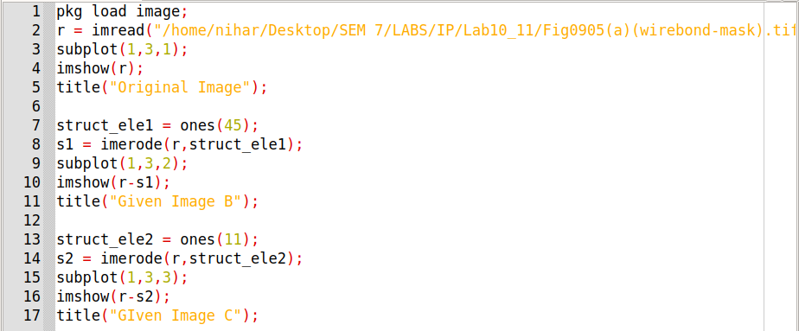

Output :

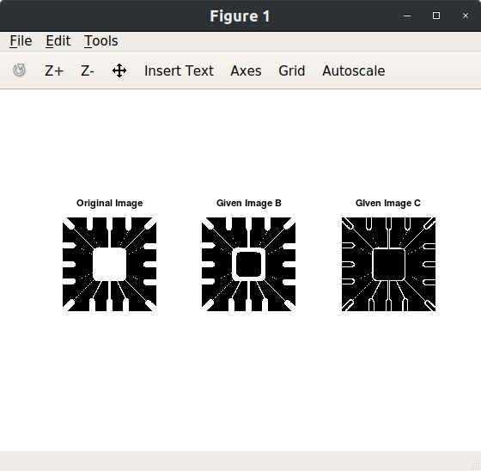

1. **Consider your black and white photo, perform erosion, dilation, opening, closing and boundary extraction. Explain the impact of size of the structuring element on these operations.**

Code :

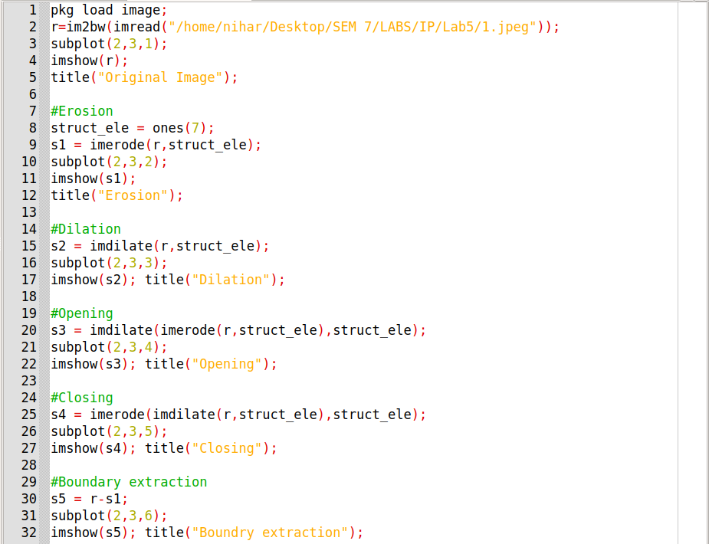

Output :

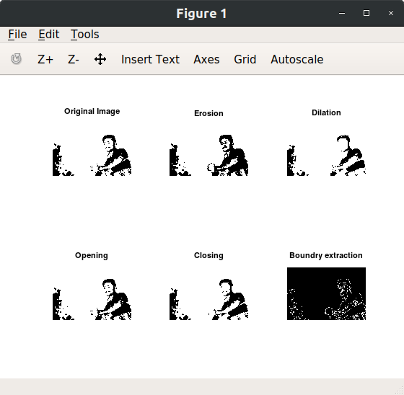

1. **Perform hole filling on your black and white photo using morphological operations.**

Code :

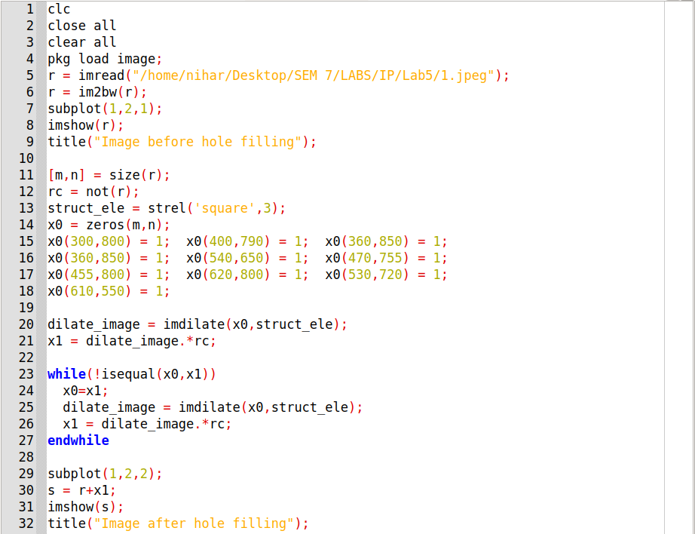

Output :

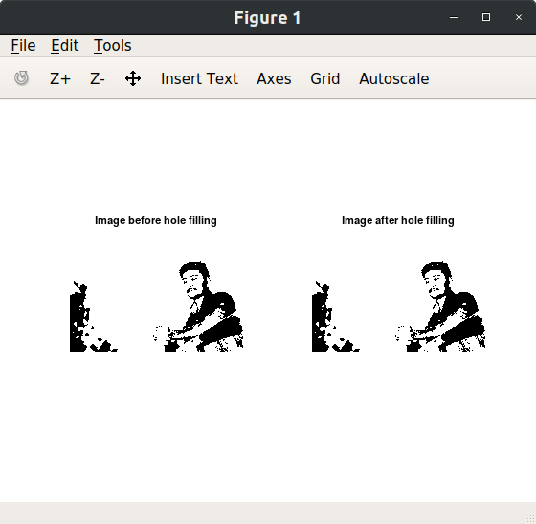

1. **Find a connected component on your black and white photo using morphological operations.**

Code :

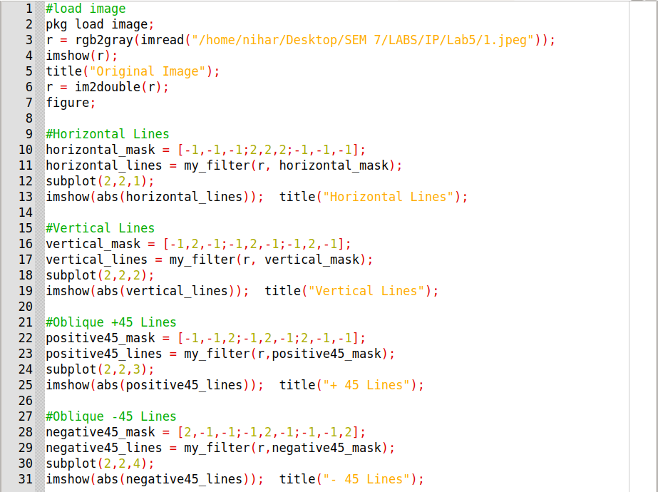

Output :

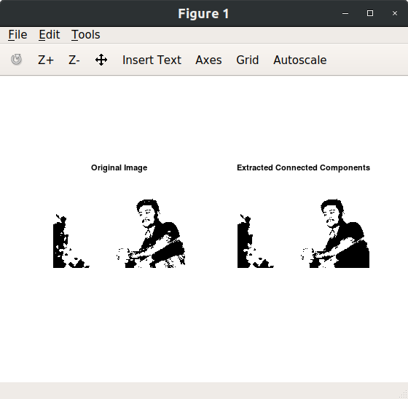

1. **Detect horizontal, vertical, diagonal(+45 degree and -45 degree) lines from your grayscale photo.**

Code :



Output :

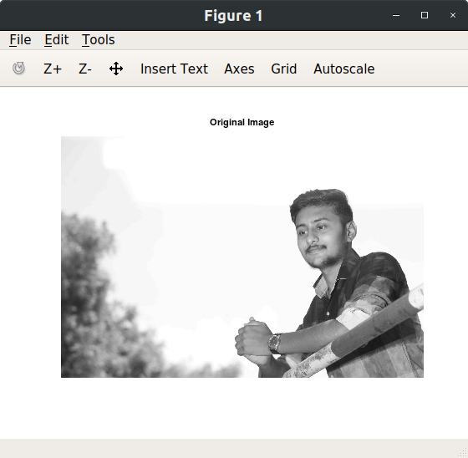

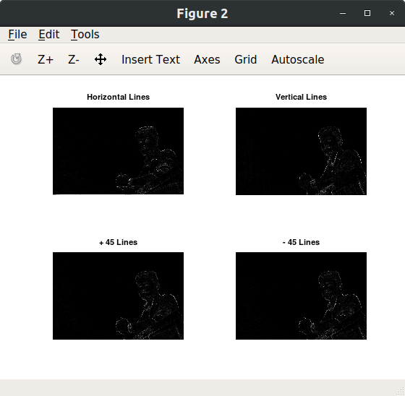

1. **Detect edges in your grayscale photo. Find gradient magnitude and angle using sobel and prewitt masks. Demonstrate the impact of smoothing on it.**

Function my_filter :

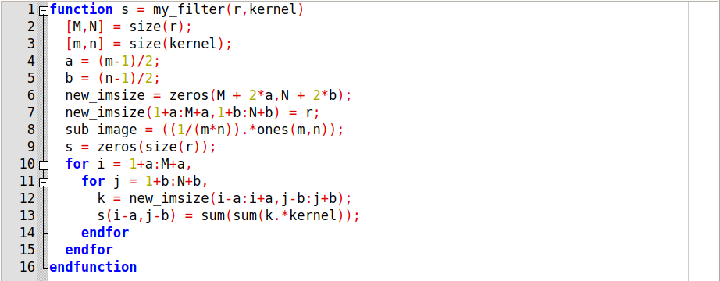

Code :

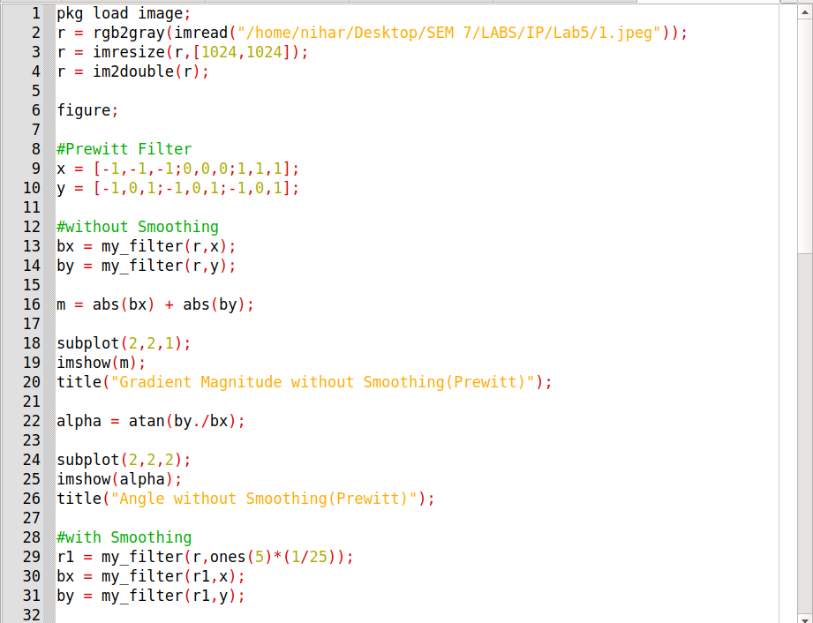

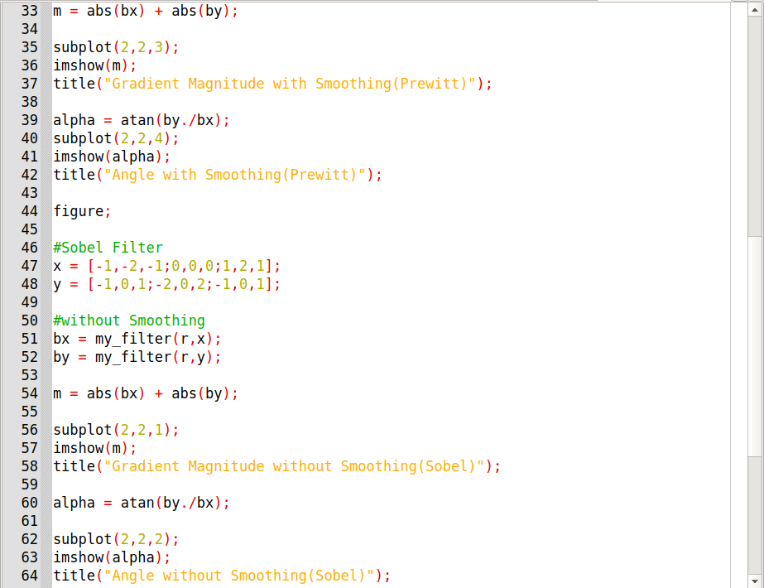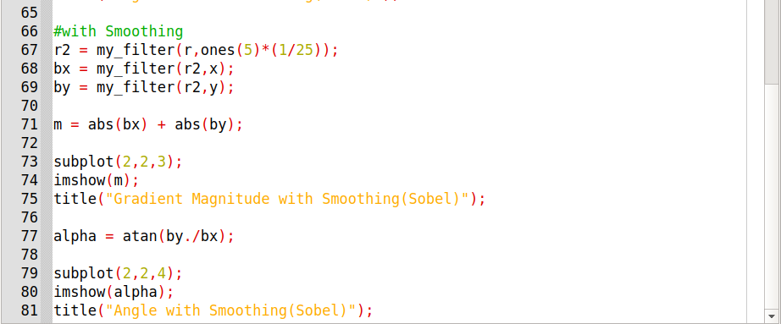

* Applying smoothing before edge detection,final  result being dominated mostly by the principal edges.

Output :

